**CS3307 – Assignment 3 – Deliverables 9 & 10 – Modified Design & Explanation**

**By: Group 6**

**Modified Design**

For our modified design we would make the Logger and Utilities classes singletons.

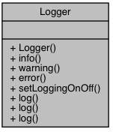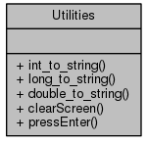

Static uniqueInstance Static uniqueInstance

+ static instance() + static instance()

*Only these classes are shown here in the redesign because even though they are now singletons, their relationships with the other classes have not changed and can be inspected in the “Classes” section of the Doxygen report in docs/html/index.html*

**Explanation**

They are accessed from all over the program so by implementing this design pattern it will help to keep a single instance of each in memory while the program is executing. Without the singleton patterns a new object is created each time a call to one of these classes is made. By creating one object of each that stays alive it increases the time efficiency of our program by having them already made up and ready to go every time they’re used.

Using singletons will also reduce the amount of global variables in the program, which add to coupling.

The singleton pattern also allows for expandability more than just static methods. Since the singleton is more object-oriented it can be extended with inheritance or polymorphism when necessary. Considering the domain of banking that may require any number of new features this will make future enhancements easier to implement.